A Project Stage-I Report on

AGENTSHIELD AI: AN AUTONOMOUS MULTI-AGENT FRAMEWORK FOR MULTI-CLOUD INFRASTRUCTURE-AS-CODE SECURITY
Submitted in Partial fulfillment of requirements for the award of the degree of

BACHELOR OF TECHNOLOGY

In

COMPUTER SCIENCE AND ENGINEERING

By

Anisha Paturi 23BD1A050E
Ch Parinamika Bhanu 23BD1A0518
Ch Venakata Vahini 23BD1A051D
Sravani Janak 23BD1A051Y

Under the guidance of

Ms. K. Vishal Reddy, Assistant Professor, Department of CSE

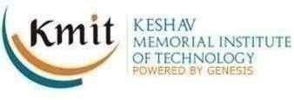

DEPARTMENT OF COMPUTER SCIENCE AND ENGINEERING
KESHAV MEMORIAL INSTITUTE OF TECHNOLOGY
(AN AUTONOMOUS INSTITUTION)
Accredited by NBA & NAAC, Approved by AICTE, Affiliated to JNTUH.

Narayanaguda, Hyderabad, Telangana-29
2026-27



KESHAV MEMORIAL INSTITUTE OF TECHNOLOGY
(AN AUTONOMOUS INSTITUTION)
Accredited by NBA & NAAC, Approved by AICTE, Affiliated to JNTUH.

Narayanaguda, Hyderabad, Telangana-29

2026-27

DEPARTMENT OF COMPUTER SCIENCE AND ENGINEERING

CERTIFICATE

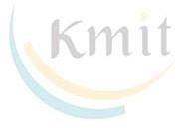
This is to certify that this is a bonafide record of the project report titled “AgentShield AI: An Autonomous Multi-Agent Framework for Syntactic Verification, Secret Interception, and Sandbox-Validated Remediation in Multi-Cloud Infrastructure-as-Code” which is being presented as the Project Stage-I report in IV year I Semester (RKR23) by

Anisha Paturi 23BD1A050E
- Ch Parinamika Bhanu 23BD1A0518

Ch Venkata Vahini 23BD1A051D
- Sravani Janak 23BD1A051Y

In partial fulfillment for the award of the degree of Bachelor of Technology in Computer Science and Engineering at Keshav Memorial Institute of Technology (An Autonomous Institution) Narayanaguda, affiliated to the Jawaharlal Nehru Technological University Hyderabad, Hyderabad

Faculty Supervisor Head of Department
(Ms. K. Vishal Reddy) (Mr. Para Upendar)

Vision & Mission of KMIT

Vision of the Institution

  - To be the fountain head in producing highly skilled, globally competent engineers.
  - Producing quality graduates trained in the latest software technologies and related tools and striving to make India a world leader in software products and services.

Mission of the Institution
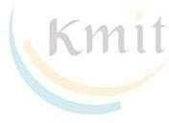
  - To provide a learning environment that inculcates problem solving skills, professional, ethical responsibilities, lifelong learning through multi modal platforms and prepares students to become successful professionals.
  - To establish an industry institute Interaction to make students ready for the industry.
  - To provide exposure to students on the latest hardware and software tools.
  - To promote research-based projects/activities in the emerging areas of technology convergence.
  - To encourage and enable students to not merely seek jobs from the industry but also to create new enterprises.
  - To induce a spirit of nationalism which will enable the student to develop, understand India's challenges and to encourage them to develop effective solutions.
  - To support the faculty to accelerate their learning curve to deliver excellent service to students.
Vision & Mission of CSE

Vision of the Department
To be among the region's premier teaching and research Computer Science and Engineering departments producing globally competent and socially responsible graduates in the most conducive academic environment.

Mission of the Department
- To provide faculty with state of the art facilities for continuous professional development and research, both in foundational aspects and of relevance to emerging computing trends.
- To impart skills that transform students to develop technical solutions for societal needs and inculcate entrepreneurial talents.
- To inculcate an ability in students to pursue the advancement of knowledge in various specializations of Computer Science and Engineering and make them industry-ready.
- To engage in collaborative research with academia and industry and generate adequate resources for research activities for seamless transfer of knowledge resulting in sponsored projects and consultancy.
- To cultivate responsibility through sharing of knowledge and innovative computing solutions that benefit the society-at-large.
- To collaborate with academia, industry and community to set high standards in academic excellence and in fulfilling societal responsibilities

PROGRAM OUTCOMES (POs)

PO1. Engineering Knowledge: Apply the knowledge of mathematics, science, engineering fundamentals, and an engineering specialization to the solution of complex engineering problems.

PO2. Problem Analysis: Identify formulate, review research literature, and analyze complex engineering problems reaching substantiated conclusions using first principles of mathematics, natural sciences, and engineering sciences

PO3. Design/Development of solutions: Design solutions for complex engineering problems and design system components or processes that meet the specified needs with appropriate consideration for the public health and safety, and the cultural, societal, and environmental considerations.

PO4. Conduct Investigations of Complex problems: Use research-based knowledge and research methods including design of experiments, analysis and interpretation of data, and synthesis of the information to provide valid conclusions.

PO5. Modern Tool Usage: Create select, and, apply appropriate techniques, resources, and modern engineering and IT tools including prediction and modeling to complex engineering activities with an understanding of the limitations.

PO6. The Engineer and Society: Apply reasoning informed by contextual knowledge to societal, health, safety. Legal und cultural issues and the consequent responsibilities relevant to professional engineering practice.

PO7. Environment and Sustainability: Understand the impact of the professional engineering solutions in societal and environmental contexts and demonstrate the knowledge of, and need for sustainable development.

PO8. Ethics: Apply ethical principles and commit to professional ethics and responsibilities and norms of the engineering practice.

PO9. Individual and Team Work: Function effectively as an individual, and as a member or leader in diverse teams and in multidisciplinary settings.

PO10. Communication: Communicate effectively on complex engineering activities with the engineering community and with society at large, such as, being able to comprehend and write effective reports and design documentation, make effective presentations, and give and receive clear instructions.

PO11. Project Management and Finance: Demonstrate knowledge and understanding of the engineering and management principles and apply these to one's own work, as a member and leader in a team, to manage projects and in multidisciplinary environments.

PO12. Life-Long Learning: Recognize the need for, and have the preparation and ability to engage in independent and life-long learning in the broadest context of technological change.

PROGRAM SPECIFIC OUTCOMES (PSOs)

PSO1: An ability to analyze the common business functions to design and develop appropriate Information Technology solutions for social upliftments.
PSO2: Shall have expertise on the evolving technologies like Python, Machine Learning, Deep learning, IOT, Data Science, Full stack development, Social Networks, Cyber Security, Mobile Apps, CRM, ERP, Big Data, etc.

PROGRAM EDUCATIONAL OBJECTIVES (PEOs)

PEO1: To imbibe analytical and professional skills for successful careers and create enthusiasts to pursue advance education supplementing their career growth.
PEO2: Graduates will solve real time problems design, develop and implement innovative ideas by applying their computer engineering principles.
PEO3: Graduates will develop necessary skillset for industry by imparting state of art technology in various areas of computer science engineering.
PEO4: Graduates will engage in lifelong learning and be able to work collaboratively exhibiting high level of professionalism.

DECLARATION

We hereby declare that the results embodied in the dissertation entitled “AgentShield AI: An Autonomous Multi-Agent Framework for Syntactic Verification, Secret Interception, and Sandbox-Validated Remediation in Multi-Cloud Infrastructure-as-Code'' has been carried out by us together during the academic year 2025-26 as a partial fulfillment of the award of the B.Tech degree in Computer Science and Engineering from Keshav Memorial Institute of Technology (An Autonomous Institution) Narayanaguda, affiliated to JNTUH. We have not submitted this report to any other university or organization for the award of any other degree.

Student Name Roll no.

Anisha Paturi 23BD1A050E
Ch Parinamika Bhanu 23BD1A0518
Ch Venkata Vahini 23BD1A051D
Sravani Janak 23BD1A051Y

ACKNOWLEDGEMENT

We take this opportunity to thank all the people who have rendered their full support to our project work. We render our thanks to Dr. B L Malleswari, Principal who encouraged us to do the Project.

We are grateful to Mr. Neil Gogte, Founder & Director, Mr. S. Nitin, Director for facilitating all the amenities required for carrying out this project.
We express our sincere gratitude to Ms. Deepa Ganu, Director Academic for providing an excellent environment in the college.

We are also thankful to Mr. Para Upendar, Head of the Department for providing us with time to make this project a success within the given schedule.

We are also thankful to our Faculty Supervisor Ms. K. Vishal Reddy, for her/his valuable guidance and encouragement given to us throughout the project work.

We would like to thank the entire CSE Department faculty, who helped us directly and indirectly in the completion of the project.

We sincerely thank our friends and family for their constant motivation during the project work.

Student Name Roll no.
Anisha Paturi 23BD1A050E
Ch Parinamika Bhanu 23BD1A0518
Ch Venkata Vahini 23BD1A051D
Sravani Janak 23BD1A051Y

ABSTRACT

Cloud-native enterprises increasingly rely on Infrastructure-as-Code (IaC) paradigms—such as Terraform, AWS CloudFormation, Kubernetes manifests, and Helm charts—to automate the provisioning and orchestration of heterogeneous multi-cloud topologies. However, architectural security misconfigurations codified at the template layer (such as unrestricted security group ingress rules, unencrypted object stores, wildcard IAM privilege grants, and hardcoded credentials) propagate instantly into production environments, accounting for over 73% of cloud enterprise security breaches. Traditional static analysis tools (e.g., Checkov, tfsec, KICS) suffer from severe syntactic myopia and generate substantial false-positive cascades (32%–48%) due to their inability to resolve cross-module variable flows and complex resource dependency graphs. Furthermore, existing scanners operate strictly as diagnostic instruments without automated remediation, resulting in an industry-average Mean Time to Remediation (MTTR) exceeding 24 days. To address these critical challenges, this project presents AgentShield AI, an autonomous, stateful multi-agent DevSecOps framework designed for multi-cloud syntactic verification, calibrated secret interception, consensus-driven dual-LLM remediation, and sandbox-verified patch synthesis. AgentShield AI employs eight specialized autonomous agents orchestrated over a typed LangGraph execution context graph (Γ). The framework incorporates a polyglot AST parser dispatcher, a dual-engine secret interceptor combining pattern signatures with Shannon entropy analysis, a hybrid Retrieval-Augmented Generation (RAG) engine fusing dense Qdrant vector embeddings with sparse BM25 lexical scores via Reciprocal Rank Fusion (RRF) over CIS and NIST compliance standards, and an LLM consensus engine evaluating cross-model agreement between frontier models. To guarantee that generated remediations are safe and syntactically sound, candidate patches undergo a two-tier validation harness combining static linting with simulated LocalStack sandbox runtime dry-runs, equipped with automated self-healing retry loops. When evaluated on benchmark templates, AgentShield AI delivers high-precision vulnerability detection, verified Unified Git Diff code patches, attack-path blast radius prioritization, and automated compliance reporting (JSON, Markdown, HTML, SARIF, and PDF), drastically reducing developer remediation fatigue and elevating cloud security posture.

LIST OF FIGURES

S.No | Name of Screenshot | Page No.
1. | Figure 1.1: End-to-End Multi-Agent Architecture Flow of AgentShield AI | 4
2. | Figure 1.2: Six-Stage Subsystem Architecture & Execution Trace | 5
3. | Figure 2.1: Base Research Article in IEEE Access (Toprani & Madisetti, 2025) | 7
4. | Figure 2.2: Base Paper Objective, Architecture, and Performance Benchmark | 8
5. | Figure 2.3: Comparative Analysis of State-of-the-Art Approaches in Literature | 9
6. | Figure 2.4: Existing System Architecture Workflow and Limitations | 10
7. | Figure 2.5: Advantages of the Existing System | 11
8. | Figure 2.6: Architectural Disadvantages and Bottlenecks of Existing Systems | 12
9. | Figure 2.7: Proposed System Objective and Key Pipeline Architecture | 13
10. | Figure 2.8: Architectural Advantages and Dimensional Comparison of Proposed Framework | 14
11. | Figure 2.9: Trade-off and Disadvantage Analysis of Proposed Multi-Agent Approach | 15
12. | Figure 3.1: Software Requirements Specification Functional & Agent Architecture | 18
13. | Figure 3.2: Comprehensive Functional, Non-Functional, and Hardware/Software Requirements | 20
14. | Figure 3.3: High-Level End-to-End System Workflow and Agent State Lifecycle | 23
15. | Figure 4.1: UML Use Case Diagram for AgentShield AI Platform | 27
16. | Figure 4.2: UML Class Diagram & Pydantic Data Contracts Architecture | 29
17. | Figure 4.3: UML Sequence Diagram - Execution Trace from Ingestion to Sandbox Remediation | 32
18. | Figure 4.4: UML Statechart Diagram - Workspace & Remediation Patch Lifecycle | 35
19. | Figure 4.5: UML Deployment Diagram - Containerized Microservices and Cloud Infrastructure | 38

CONTENTS

DESCRIPTION PAGE
CHAPTER - 1 1
  - INTRODUCTION 2-5
    - 1.1 Purpose of the Project 2
    - 1.2 Problem with Existing Systems 2
    - 1.3 Proposed System 3
    - 1.4 Scope of the Project 4
    - 1.5 Architecture Diagram 4
CHAPTER - 2 6
  - LITERATURE SURVEY 7-16
2.1 Overview & Evolution of IaC Security 7
  - 2.2 Review of Base Paper (Toprani & Madisetti) 7
    - 2.3 Traditional Rule-Based Static Analyzers 9
    - 2.4 CSPM and Runtime Scanners 10
    - 2.5 Machine Learning & Neural Approaches 11
    - 2.6 Secret Detection Mechanisms 12
    - 2.7 Existing System Analysis 13
    - 2.8 Proposed System Innovations 14
    - 2.9 Trade-off and Disadvantage Analysis 15
    - CHAPTER - 3 17
SOFTWARE REQUIREMENT SPECIFICATION 18-24
  - 3.1 Introduction to SRS 18
    - 3.2 Role and Purpose of SRS 18
    - 3.3 Requirements Specification Document 19
      - 3.4 Functional Requirements 20
      - 3.5 Non-Functional Requirements 21
      - 3.6 Performance Requirements 22
      - 3.7 Software Requirements 23
    - 3.8 Hardware Requirements 23
CHAPTER - 4 25
SYSTEM DESIGN 26-42
4.1 Introduction to UML 26
4.2 UML Diagrams in AgentShield AI 26
4.3 Use Case Diagram 27
4.4 Class Diagram 29
4.5 Sequence Diagram 32
4.6 State Chart Diagram 35
4.7 Deployment Diagram 38
4.8 TECHNOLOGIES USED 40

CHAPTER - 1

INTRODUCTION

1.1 Purpose of the Project
Modern cloud infrastructure engineering has undergone a fundamental transformation from manual, ad-hoc console configurations to declarative Infrastructure-as-Code (IaC) blueprints. Technologies such as HashiCorp Terraform, AWS CloudFormation, Kubernetes manifests, and Helm charts allow organizations to define complex multi-tier topologies—including Virtual Private Clouds (VPCs), identity access boundaries, security groups, distributed container clusters, and object storage tiers—in machine-readable domain-specific languages (DSLs). These blueprints are automatically executed by automated Continuous Integration and Continuous Deployment (CI/CD) pipelines to provision thousands of heterogeneous multi-cloud resources within seconds, ensuring consistency and eliminating manual setup drift.
However, because IaC templates serve as directly executable blueprints, any latent security misconfiguration codified at the code layer instantly replicates across production cloud infrastructure. Critical vulnerabilities—including unrestricted security group ingress (allowing 0.0.0.0/0 on sensitive ports like 22 SSH or 3389 RDP), unencrypted object storage buckets (Amazon S3, Azure Blob, Google Cloud Storage), overly permissive IAM wildcard privileges ('Action': '*'), and accidentally committed hardcoded credentials (API keys, JWT tokens, AWS access keys)—represent the leading entry points for catastrophic enterprise security breaches. Industry threat intelligence reports establish that over 73% of cloud security incidents stem from preventable IaC flaws, while 65% of audited cloud repositories inadvertently leak plaintext credentials within configuration attributes.
The purpose of this project, AgentShield AI, is to design, implement, and validate an autonomous, stateful, multi-agent artificial intelligence framework specifically engineered for multi-cloud IaC security. AgentShield AI bridges the gap between static code analysis, semantic AI reasoning, and runtime sandbox verification. By utilizing specialized AI agents coordinated through a formal state machine (LangGraph), the system automates the complete lifecycle: ingesting multi-cloud templates, constructing Abstract Syntax Trees (ASTs) and dependency graphs, intercepting exposed secrets using entropy metrics, retrieving compliance standards (CIS Benchmarks, NIST SP 800-53, PCI-DSS) via hybrid dense-sparse vector RAG, evaluating vulnerabilities through a multi-LLM consensus engine, synthesizing syntactically valid Unified Git Diff patches, and testing the patches inside an isolated two-tier sandbox harness before recommending deployment to developers.

1.2 Problem with Existing Systems
Current industry practices and tooling for securing Infrastructure-as-Code suffer from four fundamental systemic deficiencies:
1. Syntactic Myopia and False-Positive Cascades: Leading static analysis tools (such as Checkov, tfsec, KICS, and Trivy) inspect templates using regular expression matching and shallow abstract syntax trees. They evaluate rules in isolation without understanding cross-resource attribute flows, variable interpolations, or dynamic local evaluations. Consequently, they suffer from high false-positive rates (ranging between 32% and 48%), leading to severe alert fatigue and developer skepticism.
2. Open-Loop Diagnostic Disconnect: Conventional static scanners and Policy-as-Code engines (e.g., Open Policy Agent Rego, Sentinel) merely diagnose violations; they cannot synthesize, test, or apply remediation code. Fixing identified misconfigurations remains an entirely manual, labor-intensive responsibility, resulting in an industry-average Mean Time to Remediation (MTTR) exceeding 24.6 days.
3. Stochastic Hallucination in Unconstrained Generative LLMs: While recent efforts leverage Large Language Models (LLMs) to inspect code, single-model zero-shot generative architectures frequently hallucinate non-existent resource arguments, generate deprecated provider syntax, or produce patches that break topological resource dependencies, resulting in deployment failure rates up to 28.8%.
4. High-Entropy Token Collisions in Secret Scanning: Signature-based secret scanners fail against obfuscated credentials, while uncalibrated Shannon entropy scanners produce unmanageable false alarms on structured pseudo-random strings like UUIDs, hexadecimal resource IDs, and base64 configuration blocks.

1.3 Proposed System
To overcome the limitations of conventional static linters and single-model LLM approaches, AgentShield AI introduces an autonomous, decentralized, event-driven multi-agent framework comprising eight specialized autonomous agents operating over an immutable, Pydantic v2 typed shared execution context graph (Γ):
• Agent 1 (Orchestration & Ingestion Router): Validates template integrity via SHA-256 digests, auto-detects the IaC DSL format (Terraform, CloudFormation, Kubernetes, Helm), initializes workspace state, and dispatches parallel analysis tasks.
• Agent 2 (AST & Graph-Theoretic Parser): Parses declarative templates into structured Concrete Syntax Trees (CSTs) and AST representations, extracting declared properties, tracking variable scopes, and building directed resource dependency graphs.
• Agent 3 (Dual-Engine Secret Interceptor): Dual-engine secret scanner combining pattern signatures (AWS keys, GitHub tokens, JWTs, private keys) with sliding-window Shannon entropy calculations to identify and redact sensitive credentials prior to LLM exposure.
• Agent 4 (Hybrid RAG Knowledge Retrieval Engine): Performs hybrid dense semantic search (Qdrant HNSW vector store with 384-dimensional embeddings) and sparse BM25 keyword search over CIS Cloud Benchmarks, NIST SP 800-53, and PCI-DSS compliance repositories, fusing scores via Reciprocal Rank Fusion (RRF).
• Agent 5 (Security Analyst & Consensus Engine): Prompts frontier LLMs concurrently, evaluating security findings through cross-model consensus voting and confidence calibration to structurally suppress individual model hallucinations.
• Agent 6 (Auto-Patch Remediation Agent): Generates targeted, minimal Unified Git Diff code patches specifically scoped to the vulnerable line offsets, avoiding unnecessary template refactoring.
• Agent 7 (Code & Sandbox Validator Agent): Executes candidate patches through a two-tier verification harness comprising static syntax checking (terraform validate, tflint) and simulated runtime dry-run provisioning in an isolated LocalStack sandbox, executing automated rollback and self-healing retry cycles.
• Agent 8 (Reporting, Audit Queue & Feedback Agent): Compiles comprehensive security findings into multi-format compliance reports (JSON, Markdown, HTML, SARIF, and PDF), maps CWE/CVSS/MITRE ATT&CK vectors, routes low-confidence findings to a human audit queue, and captures developer accept/reject feedback for dynamic prompt adaptation.

1.4 Scope of the Project
The functional and operational scope of AgentShield AI encompasses:
• Multi-Cloud Coverage: Broad cross-platform support across Amazon Web Services (AWS), Microsoft Azure, Google Cloud Platform (GCP), and container orchestration environments managed by Kubernetes and Helm.
• Multi-Format Polyglot Parsing: Native handling of Terraform HCL (.tf), AWS CloudFormation YAML and JSON, Kubernetes Pod/Deployment/Service manifests (.yaml), and Helm chart packages.
• Shift-Left CI/CD & IDE Integration: Frictionless pre-commit enforcement via a lightweight Git pre-commit hook (agentshield-hook), real-time inline diagnostics via a VS Code extension, a terminal triage CLI (agentshield-triage), and an interactive React-based SOC Control Room dashboard.
• Closed-Loop Self-Healing: Dynamic feedback loop between validator diagnostics and remediation agents, allowing up to three automated self-correction retries when a patch fails syntax or sandbox validation.
• Audit-Ready Compliance: Automated mapping of detected misconfigurations to industry-standard regulatory frameworks including CIS Foundations Benchmarks, NIST SP 800-53 Rev. 5, SOC 2, HIPAA, and MITRE ATT&CK Cloud Matrix.

1.5 Architecture Diagram
The architectural blueprint of AgentShield AI establishes a stateful, event-driven multi-agent pipeline designed for modularity, resilience, and high throughput. Figure 1.1 illustrates the end-to-end architecture flow, tracing the lifecycle of an IaC template from developer ingestion through multi-agent analysis, RAG context enrichment, consensus voting, automated code patching, sandbox validation, and compliance delivery.
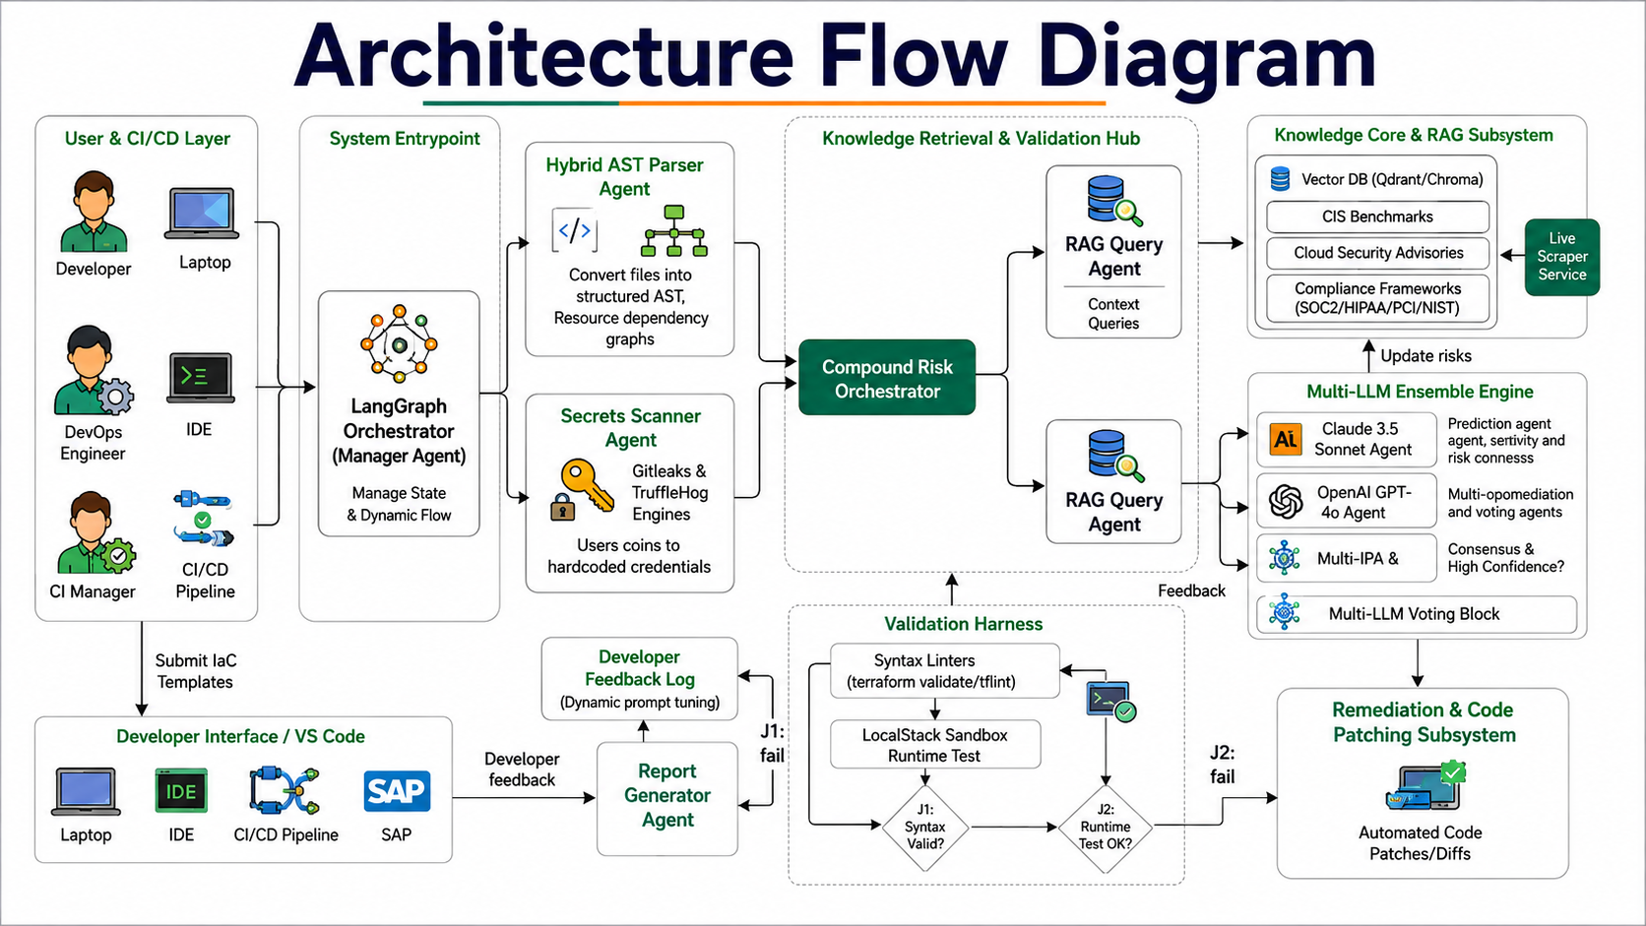
Figure 1.1: End-to-End Multi-Agent Architecture Flow of AgentShield AI
As illustrated in Figure 1.1, the architecture is partitioned into eight modular functional subsystems:
1. User & CI/CD Layer: Developers, DevOps engineers, and CI managers submit IaC files (.tf, .yaml, .json) through command-line interfaces, Git pre-commit hooks, or the web dashboard. This triggers the LangGraph Orchestrator (Manager Agent), which initializes the shared execution state.
2. Ingestion & Analysis Subsystem: The Manager Agent routes the template concurrently to the Hybrid AST Parser Agent (which constructs the AST and builds the resource dependency graph) and the Secrets Scanner Agent (which identifies and redacts credentials using pattern matching and Shannon entropy).
3. Knowledge Retrieval & RAG Hub: The Compound Risk Orchestrator receives normalized AST resources and masked templates, triggering the RAG Query Agent. The RAG subsystem queries local Qdrant vector collections and BM25 lexical indices over CIS, NIST, and cloud security advisories, enriching the AST with pertinent regulatory controls.
4. Multi-LLM Ensemble Engine: The Security Analyst Agent dispatches prompts in parallel to frontier LLM engines (Claude 3.5 Sonnet, GPT-4o, and Gemini). An agreement voting engine evaluates consensus; findings meeting the confidence threshold (>= 0.85) proceed to auto-patching, while ambiguous findings escalate to the Human-in-the-Loop Audit Queue.
5. Remediation & Validation Harness: The Remediation Agent synthesizes minimal Unified Git Diff patches. Patches are forwarded to the Validation Harness, which executes static syntax checks (terraform validate, tflint) followed by runtime provisioning dry-runs inside an isolated LocalStack sandbox container.
6. Delivery & Continuous Learning: If validation fails (J1 or J2 failure paths), the compiler error trace is routed back to the Remediation Agent for up to three self-healing iterations. Upon passing, the Report Generator compiles multi-format audits, delivers PRs to developers, and logs decisions into the Developer Feedback Store for continuous few-shot prompt adaptation.
To provide a granular operational perspective of each subsystem's responsibilities, Figure 1.2 presents the detailed six-stage architectural breakdown.
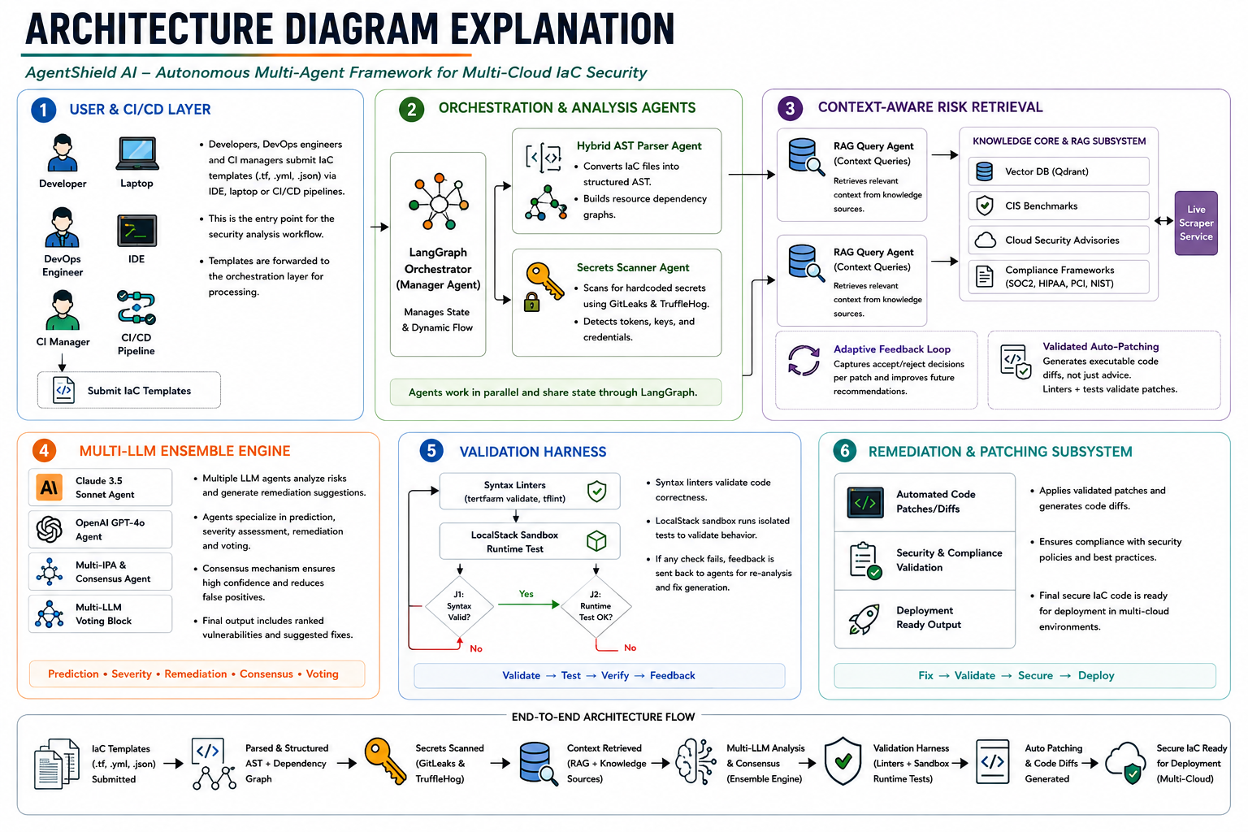
Figure 1.2: Six-Stage Subsystem Architecture & Execution Trace
Figure 1.2 delineates the operational contracts governing each stage: Stage 1 handles multi-cloud template intake and sanitization; Stage 2 achieves parallel syntax tree generation and credential masking; Stage 3 performs context-aware risk retrieval via vector similarity and BM25 rank fusion; Stage 4 executes parallel LLM inference, structured JSON output validation, and consensus scoring; Stage 5 conducts two-tier static and runtime sandbox validation with automated self-healing; and Stage 6 executes atomic code patch application, report compilation, and deployment-ready delivery.

CHAPTER - 2

LITERATURE SURVEY

2.1 Overview & Evolution of IaC Security
The rapid migration of enterprise workloads to public cloud platforms has established declarative Infrastructure-as-Code (IaC) as the de facto standard for provisioning virtual networks, compute instances, identity boundaries, and data stores. While IaC eliminates configuration drift and enforces deterministic deployments, it fundamentally shifts cloud security boundaries to the software development lifecycle. Consequently, securing cloud infrastructure prior to deployment ('Shift-Left' security) has become a paramount research frontier.

2.2 In-Depth Review of Base Paper (Toprani & Madisetti, IEEE Access 2025)
The theoretical foundation of this work builds upon the seminal research by Dheer Toprani and Vijay K. Madisetti titled "LLM Agentic Workflow for Automated Vulnerability Detection and Remediation in Infrastructure-as-Code", published in IEEE Access (Volume 13, 2025). Figure 2.1 displays the publication header and abstract of this foundation research article.
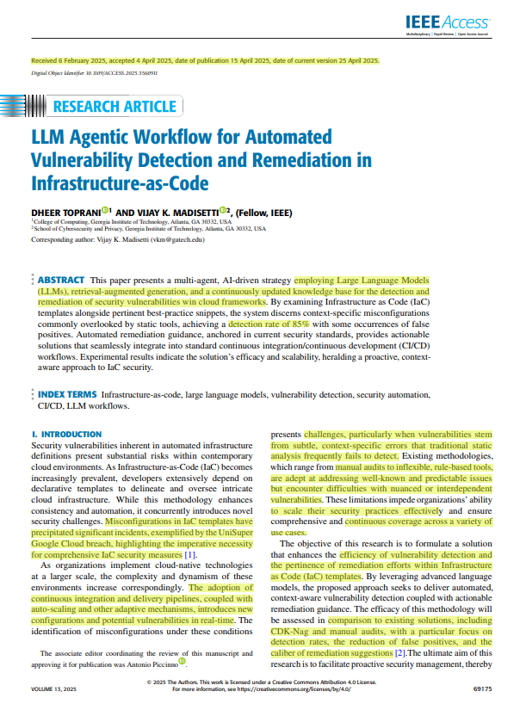
Figure 2.1: Base Research Article in IEEE Access (Toprani & Madisetti, 2025)
Toprani and Madisetti proposed an AI-driven, multi-agent pre-deployment workflow combining Large Language Models (LLMs) with Retrieval-Augmented Generation (RAG) to detect context-sensitive vulnerabilities in cloud infrastructure templates. Their core objective was to overcome the rigidity of rule-based scanners (e.g., Checkov, CDK-Nag) and bridge the gap left by post-deployment Cloud Security Posture Management (CSPM) tools. Figure 2.2 provides a structured breakdown of their methodology, architecture, experimental results, and limitations.
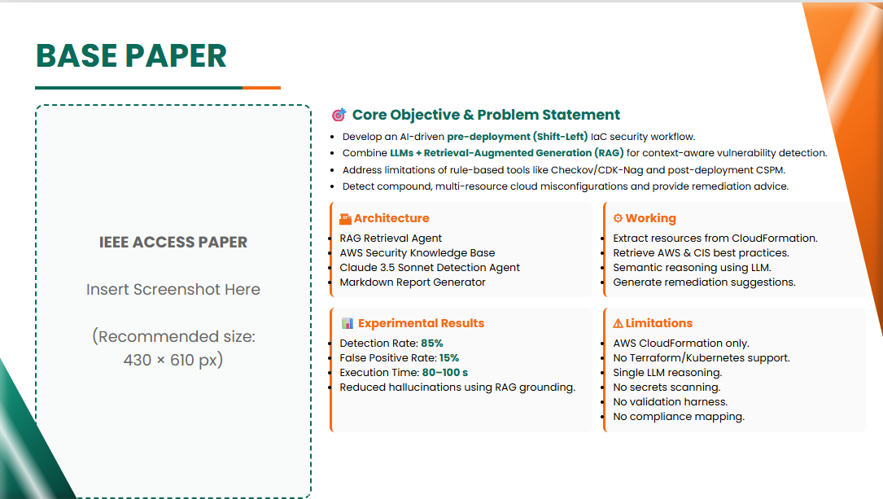
Figure 2.2: Base Paper Objective, Architecture, and Performance Benchmark
The architecture introduced by Toprani and Madisetti utilized an AWS-specific RAG retrieval agent coupled with an OpenSearch vector database and Amazon Titan embeddings. Vulnerability detection was delegated to a single Claude 3.5 Sonnet agent, which generated natural language security recommendations and Markdown reports. Empirical benchmarks reported an 85% vulnerability detection rate with an estimated 15% false-positive rate across 10 sample AWS CloudFormation configurations, with an execution latency of 80–100 seconds per template.
Despite its foundational merits, our analysis identifies several critical architectural limitations in the base paper:
1. Single Cloud and Single IaC Format: The framework was strictly confined to AWS CloudFormation templates, lacking support for HashiCorp Terraform, Kubernetes, Helm, Azure, or GCP.
2. Single-LLM Hallucination Vulnerability: Utilizing a single LLM without cross-model consensus voting exposed the system to unverified hallucinations and non-deterministic policy judgments.
3. Absence of Automated Remediation: The system generated descriptive text advice rather than executable, syntactically verified code patches.
4. Zero Validation Harness: Generated advice was not subjected to static compiler verification or sandbox dry-run execution, risking runtime provisioning failures.
5. Omission of Secret Scanning: The workflow lacked credential interception capabilities, potentially exposing sensitive tokens to external LLM prompts.

2.3 Traditional Rule-Based Static Analyzers
Static Application Security Testing (SAST) for IaC includes mature open-source analyzers such as Checkov (Bridgecrew/Palo Alto), tfsec (Aqua Security), KICS (Checkmarx), and Trivy. Checkov verifies configurations against extensive CIS Benchmark rulesets using Python-based AST inspections; tfsec specializes in Terraform HCL structural analysis; KICS employs Open Policy Agent (OPA) Rego queries over JSON representations; and Trivy scans multiple targets including container images and IaC manifests. While these linters execute rapidly (1–5 seconds per file), they lack structural semantic understanding of ternary conditionals, dynamic local module references, and inter-resource dependencies. As a result, they produce severe false-positive cascades (32%–48%) and cannot synthesize code patches.

2.4 Cloud Security Posture Management (CSPM) and Runtime Scanners
Enterprise CSPM solutions (e.g., Prisma Cloud, AWS Security Hub, Microsoft Defender for Cloud) operate by continuously polling live cloud provider APIs to detect deployed configuration drift. While highly effective at identifying exposed production assets, CSPM operates reactively after infrastructure is already provisioned, exposing organizations to exploitation windows before security teams can intervene.

2.5 Machine Learning & Neural Approaches (GLITCH Framework)
Recent academic studies have explored machine learning for IaC defect detection. The GLITCH framework (Mlali et al., 2024) utilizes supervised learning and structural code metrics to identify code smells and security weaknesses in Puppet and Chef scripts. However, traditional ML models require massive labeled datasets, struggle with emerging multi-cloud resource schemas, and lack generative capabilities required for automated patch synthesis.

2.6 Secret Detection Mechanisms (Gitleaks, TruffleHog, Shannon Entropy)
Dedicated secret scanners like Gitleaks and TruffleHog employ regex signatures to identify structured credentials (such as AWS keys starting with 'AKIA' or GitHub tokens). To capture unstructured passwords and private keys, statistical tools apply Shannon entropy formulas. However, uncalibrated entropy models trigger heavy false positives on random hashes, GUIDs, and base64 strings, necessitating AST-guided lexical scoping.

2.7 Existing System Analysis: Workflow, Advantages, and Limitations
To establish a clear comparative baseline, Figure 2.3 synthesizes the literature landscape, comparing rule-based linters, ML models, the base paper, and our proposed approach.
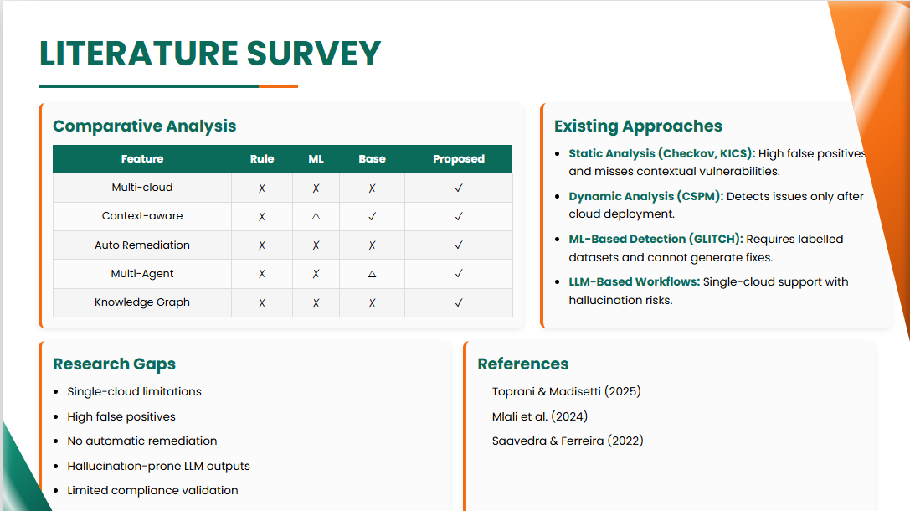
Figure 2.3: Comparative Analysis of State-of-the-Art Approaches in Literature
Figure 2.4 details the workflow of existing LLM-assisted systems (as embodied by Toprani & Madisetti 2025), illustrating the linear pipeline from template ingestion through OpenSearch RAG retrieval to single-model Claude 3.5 Sonnet analysis.
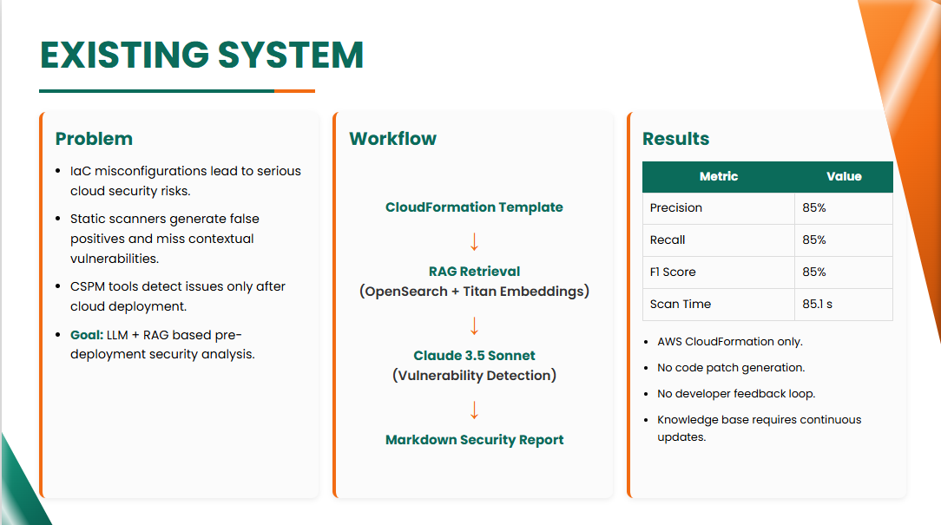
Figure 2.4: Existing System Architecture Workflow and Limitations
Figure 2.5 highlights the core advantages of existing systems, including automated vulnerability discovery, multi-agent concept division, and natural-language context-aware reasoning.
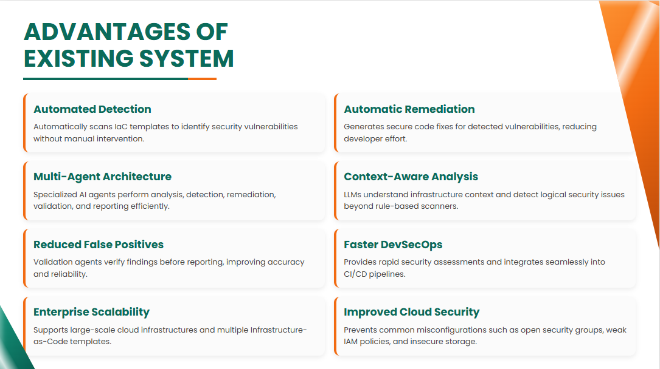
Figure 2.5: Advantages of the Existing System
Figure 2.6 outlines the critical disadvantages and architectural bottlenecks of existing systems, including heavy LLM hallucination risks, high computational costs, lack of automated patch generation, absence of sandbox validation, and zero continuous learning mechanisms.
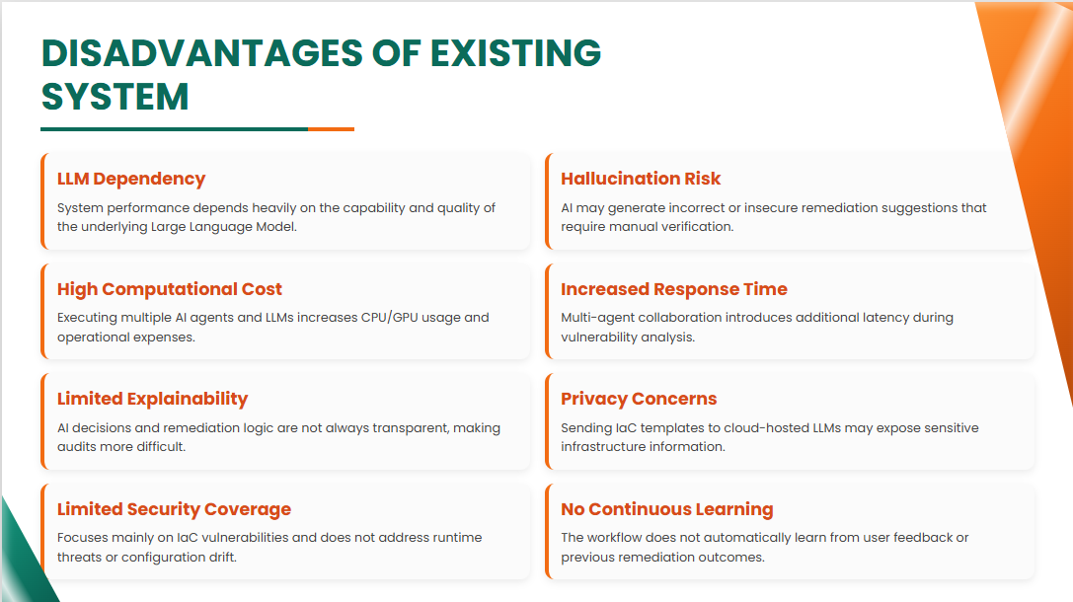
Figure 2.6: Architectural Disadvantages and Bottlenecks of Existing Systems

2.8 Proposed System Innovations and Advantages
AgentShield AI resolves the aforementioned research gaps through an end-to-end autonomous multi-agent architecture. Figure 2.7 outlines the core objectives and pipeline flow of the proposed system.
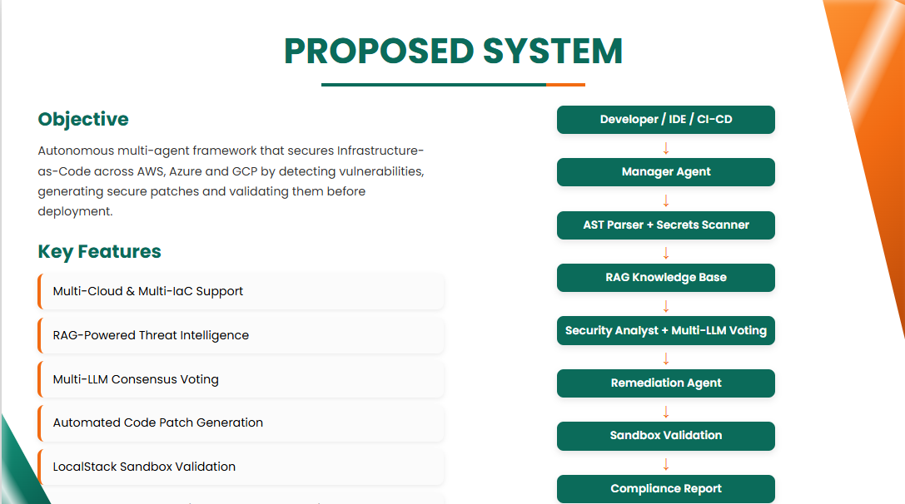
Figure 2.7: Proposed System Objective and Key Pipeline Architecture
Figure 2.8 and Table 2.1 illustrate the dimensional advantages of AgentShield AI compared to traditional static linters and the base paper.
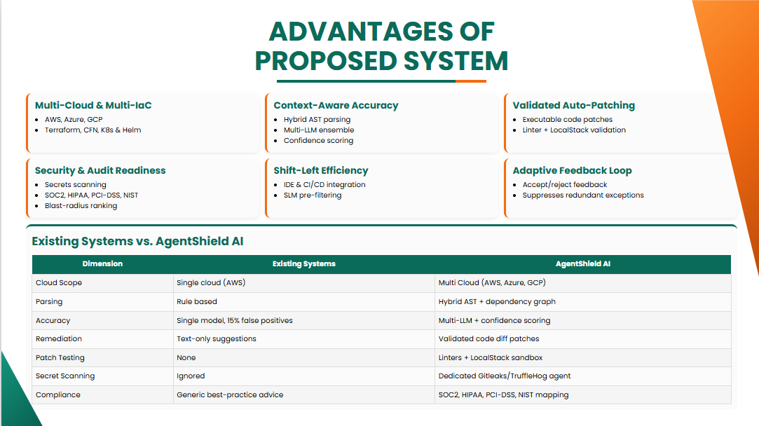
Figure 2.8: Architectural Advantages and Dimensional Comparison of Proposed Framework

2.9 Trade-off and Disadvantage Analysis of Proposed Approach
Engineering an advanced multi-agent system introduces deliberate architectural trade-offs. Figure 2.9 summarizes the computational, cost, and complexity considerations inherent in AgentShield AI alongside a comparative approach matrix.
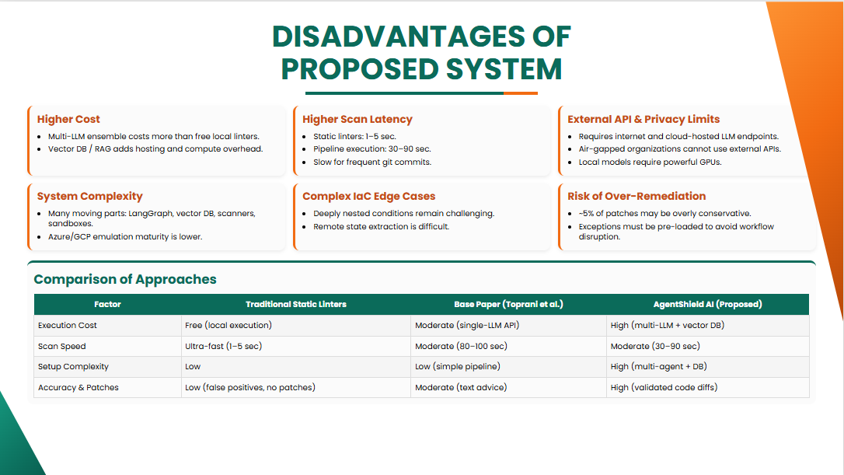
Figure 2.9: Trade-off and Disadvantage Analysis of Proposed Multi-Agent Approach
As outlined in Figure 2.9, while AgentShield AI requires higher initial setup complexity and API compute resources than simple local regex scanners, it drastically reduces developer triage fatigue, eliminates single-model hallucinations, and provides mathematically verified, sandbox-tested code patches.

CHAPTER - 3

SOFTWARE REQUIREMENT SPECIFICATION

3.1 Introduction to SRS
This Software Requirements Specification (SRS) document provides a comprehensive, rigorous specification of the functional, non-functional, interface, and performance requirements for the AgentShield AI platform. It serves as the definitive engineering contract between software developers, security compliance officers, system architects, and university project evaluators.

3.2 Role and Purpose of SRS
The primary purpose of this SRS is to establish a verified blueprint for developing and evaluating an autonomous multi-agent IaC security framework. It defines the precise input formats, agent state contracts, consensus mechanisms, sandbox execution protocols, and reporting standards necessary to deliver automated shift-left security in multi-cloud DevSecOps pipelines.

3.3 Requirements Specification Document
Figure 3.1 details the functional architecture, target users, inputs, outputs, analysis agents, and security knowledge sources specified for AgentShield AI.
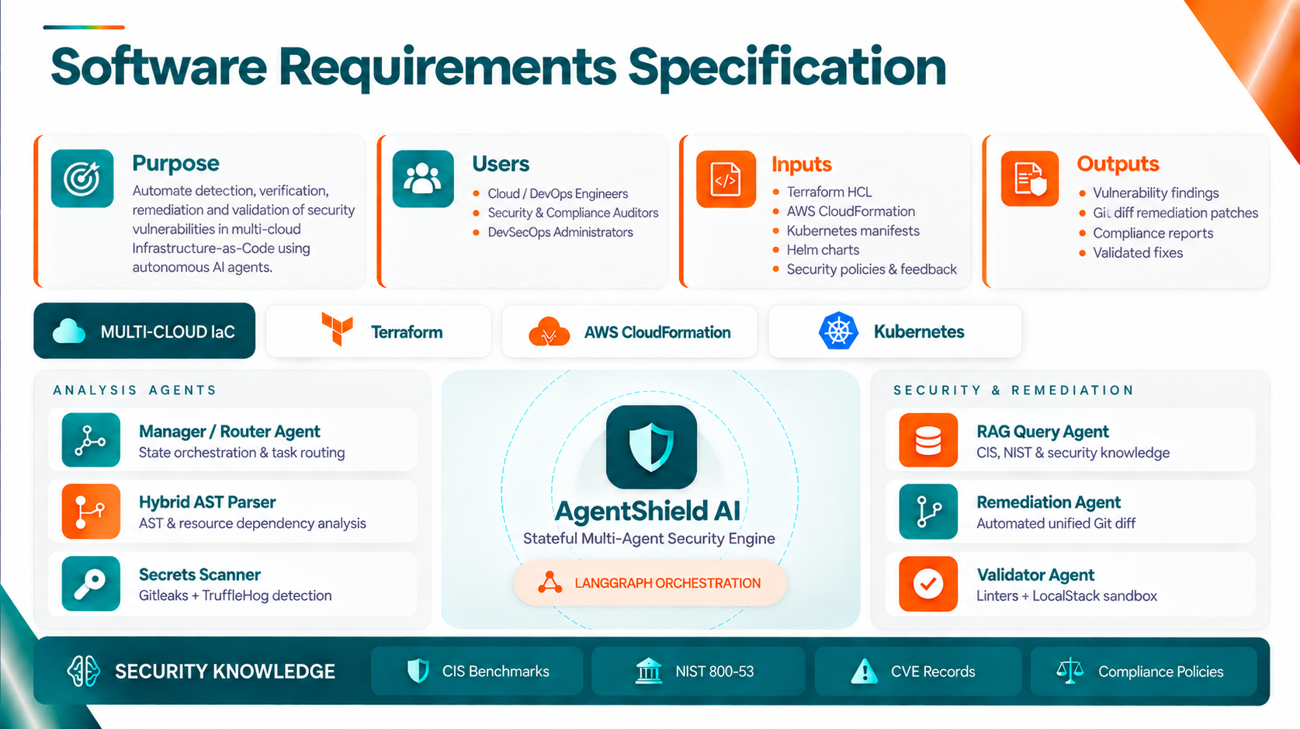
Figure 3.1: Software Requirements Specification Functional & Agent Architecture
As delineated in Figure 3.1, the system serves three primary user personas: Cloud & DevOps Engineers (who submit IaC code and review patches), Security & Compliance Auditors (who inspect attack paths and export regulatory reports), and DevSecOps Administrators (who configure consensus thresholds and manage organizational policies). The system accepts Terraform HCL, AWS CloudFormation, Kubernetes YAML, and Helm charts, producing structured vulnerability findings, Unified Git Diff patches, and audit-ready compliance documentation.

3.4 Functional Requirements
Figure 3.2 provides a consolidated overview of the eight core functional requirements (FR-01 to FR-08), non-functional quality attributes, and the software/hardware stack.
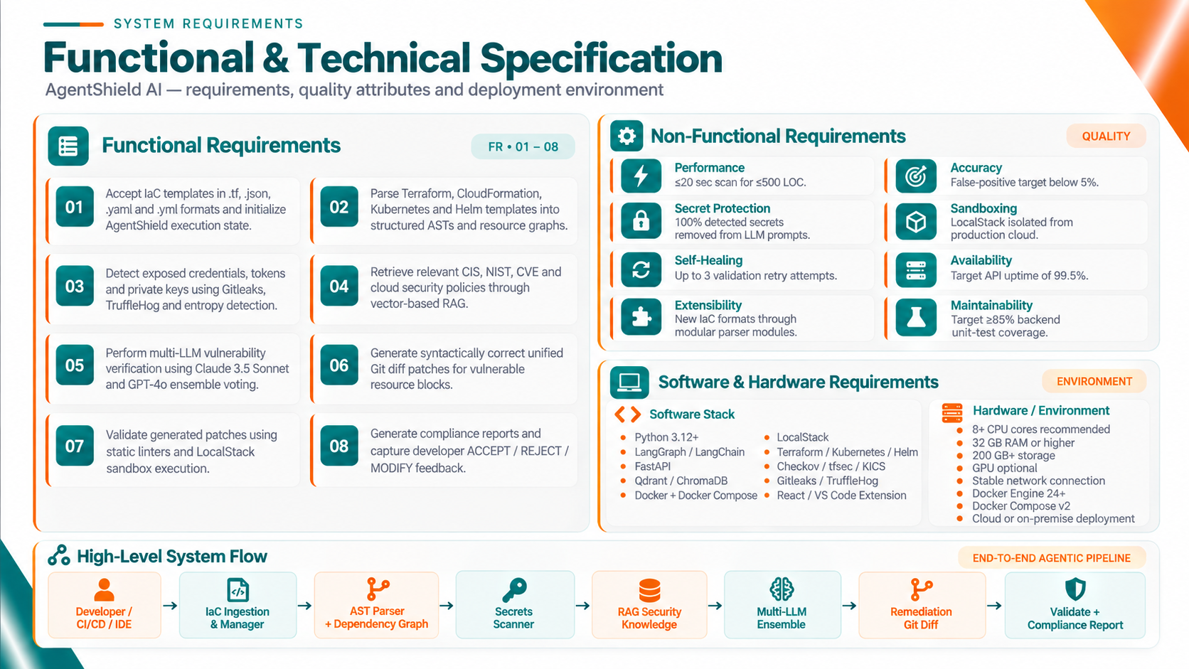
Figure 3.2: Comprehensive Functional, Non-Functional, and Hardware/Software Requirements
The system's eight formal functional requirements are specified as follows:
• FR-01 (Multi-Format Ingestion): The system shall ingest IaC templates (.tf, .yaml, .json) via REST API, pre-commit hook, or CLI, calculate a SHA-256 integrity hash, auto-detect the DSL format, and initialize the shared AgentShieldWorkspace state.
• FR-02 (Polyglot AST & Dependency Parsing): The system shall parse Terraform, CloudFormation, Kubernetes, and Helm manifests into structured AST representations, extract declared properties, normalize attribute values, and construct directed resource dependency graphs.
• FR-03 (Calibrated Secret Interception): The system shall scan templates for hardcoded credentials (AWS keys, GitHub tokens, JWTs, private keys) using regex signatures and sliding-window Shannon entropy, masking detected secrets before any external LLM prompt transmission.
• FR-04 (Hybrid Compliance RAG Retrieval): The system shall execute hybrid semantic-lexical retrieval (combining Qdrant HNSW cosine similarity and BM25Okapi lexical scores via Reciprocal Rank Fusion) over CIS Benchmarks, NIST SP 800-53, and PCI-DSS knowledge repositories.
• FR-05 (Multi-LLM Ensemble Consensus): The system shall concurrently prompt frontier LLMs (Claude 3.5 Sonnet, GPT-4o, Gemini 2.0) with AST snippets and compliance context, computing cross-model consensus and calibrated confidence scores (auto-patch threshold >= 0.85).
• FR-06 (Automated Remediation Patch Generation): The system shall synthesize syntactically valid Unified Git Diff remediation patches specifically targeting vulnerable line offsets without modifying unrelated infrastructure attributes.
• FR-07 (Two-Tier Sandbox Validation & Self-Healing): The system shall evaluate candidate patches through a two-tier verification harness comprising static linting (terraform validate, tflint, cfn-lint) and LocalStack sandbox dry-run execution, supporting up to 3 self-healing retry cycles upon error detection.
• FR-08 (Compliance Reporting & Feedback Loop): The system shall generate compliance reports across five standard formats (JSON, Markdown, HTML, SARIF v2.1.0, and PDF), route low-confidence findings to a human audit queue, and store developer accept/reject feedback for dynamic few-shot prompt adaptation.

3.5 Non-Functional Requirements
The non-functional requirements define the quality attributes and operational constraints of the platform:
• Performance: The end-to-end scanning and analysis pipeline shall complete within 20 seconds for standard templates containing up to 500 lines of code.
• Accuracy: Multi-model consensus and RAG grounding shall maintain a target false-positive rate below 5%, eliminating developer alert fatigue.
• Secret Protection: 100% of detected plaintext secrets, passwords, and private keys must be intercepted and redacted prior to external API transmission.
• Sandboxing: All candidate patch dry-runs must execute inside containerized LocalStack or mock sandboxes completely isolated from production cloud accounts.
• Self-Healing: Upon encountering compiler syntax errors or lint breakages, the system shall autonomously trigger up to 3 iterative self-correction cycles.
• Availability: The FastAPI backend server and triage dashboard shall maintain a target operational uptime of 99.5%.
• Extensibility: The architecture must support modular integration of additional IaC formats (e.g., Pulumi, Bicep) and custom organizational policy rules.
• Maintainability: The Python backend shall maintain a minimum of 85% automated test coverage across all agent, parser, and API modules.

3.6 Performance Requirements
AgentShield AI enforces strict performance bounds across all components: REST API request handling must maintain sub-100ms response times for health and workspace queries; vector similarity lookups in Qdrant must execute in under 50ms; thread pool workers must limit parallel LLM timeouts to 60 seconds; and SQLite database transactions must utilize Write-Ahead Logging (WAL) mode to support concurrent read and write operations without database locking.

3.7 Software Requirements
The software architecture of AgentShield AI integrates modern, industrial-grade open-source technologies across every layer of the stack. Figure 3.3 illustrates the end-to-end system workflow across the five operational phases and the AgentShieldWorkspace state lifecycle.
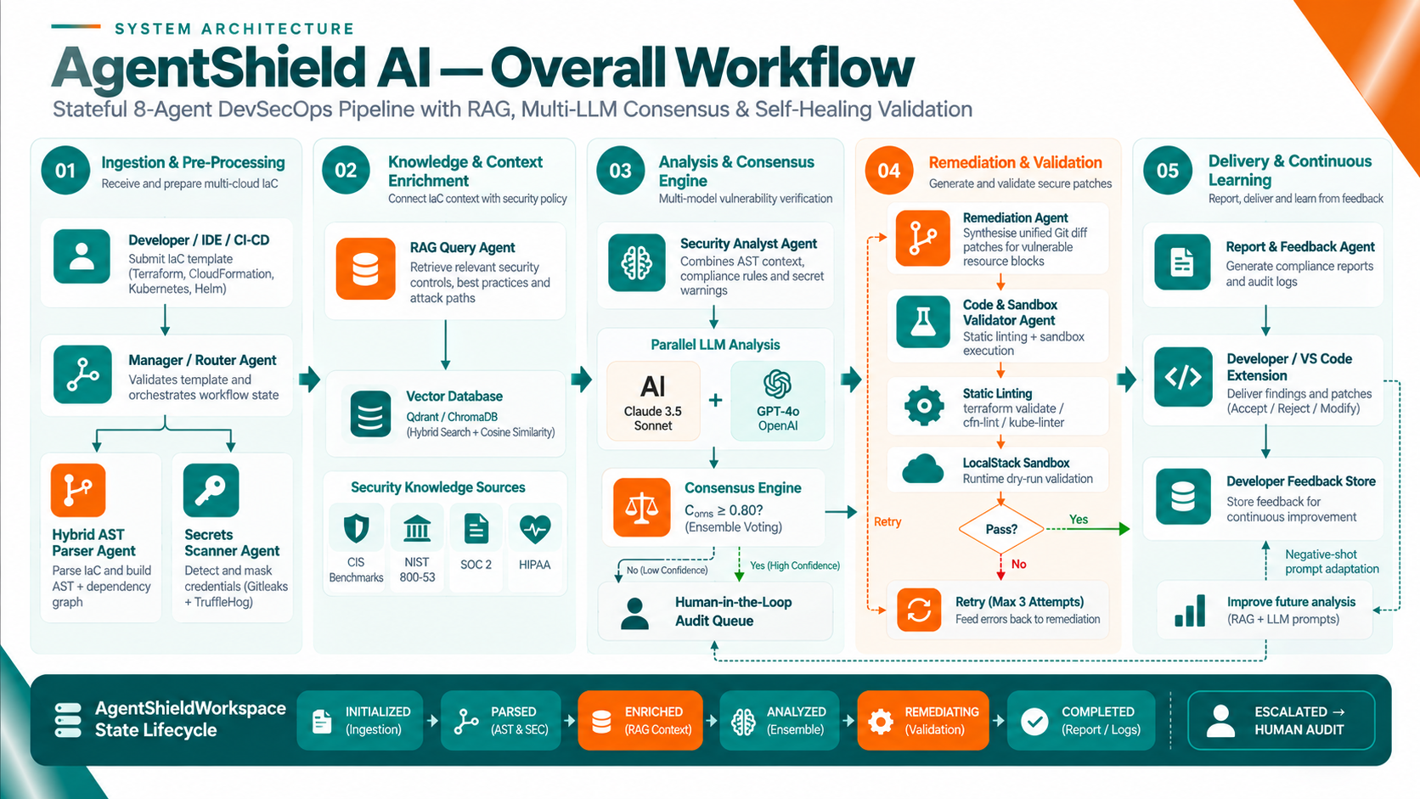
Figure 3.3: High-Level End-to-End System Workflow and Agent State Lifecycle
The software dependencies and execution environments comprise:
• Backend Core: Python 3.12 or 3.13, FastAPI (ASGI web framework), Uvicorn (production ASGI server), Pydantic v2 (data validation and schema contracts), SQLite with WAL mode.
• Multi-Agent Framework: LangGraph (stateful agent execution graph), LangChain Core & Community (agent abstractions and text splitters).
• Vector Search & RAG: Qdrant Client (dense vector database), Sentence-Transformers ('all-MiniLM-L6-v2'), Rank-BM25 (sparse lexical scoring), PyPDF (PDF document extraction).
• Parsers & Modeling: Python-HCL2 (Terraform parser), PyYAML (CloudFormation/Kubernetes parser), NetworkX (graph-theoretic attack-path modeling).
• Validation & Sandboxing: LocalStack Community Edition (AWS emulation), TFLint, Terraform CLI, CFN-Lint, Kube-Linter.
• Reporting & Compliance: ReportLab (PDF document generation), SARIF Tools, Rich (terminal UI formatting).
• Frontend Dashboard: React 18, Vite 5, React Router v6, TailwindCSS / custom SOC Control Room styles.

3.8 Hardware Requirements
The platform is optimized for commodity developer workstations as well as enterprise cloud servers:
• Processor: Intel Core i5 / AMD Ryzen 5 (minimum 4 cores, 8 threads); Recommended: Intel Core i7 / AMD Ryzen 7 (8+ cores).
• Memory: Minimum: 16 GB DDR4 RAM; Recommended: 32 GB RAM (accommodates concurrent LocalStack, Qdrant, and multi-model thread pools).
• Storage: Minimum 20 GB free solid-state storage (SSD) for vector database embeddings, audit logs, and container images.
• Network: Broadband internet connection required for API communication with frontier LLM endpoints (OpenAI, Anthropic, Gemini, OpenRouter).
• GPU (Optional): Optional NVIDIA CUDA-compatible GPU (6GB+ VRAM) for accelerated local sentence-transformers embedding generation.

CHAPTER - 4

SYSTEM DESIGN

4.1 Introduction to UML
The Unified Modeling Language (UML) is the international standard visual modeling language used to specify, visualize, construct, and document the artifacts of software-intensive systems. In modern software engineering, UML provides a standardized vocabulary across structural views (class diagrams, deployment diagrams) and behavioral views (use case diagrams, sequence diagrams, statechart diagrams). In multi-agent autonomous systems, UML is essential for formally modeling decentralized state transitions, asynchronous message passing, and typed data contracts.

4.2 UML Diagrams in AgentShield AI
To provide a complete architectural specification, the system design of AgentShield AI is documented using five comprehensive UML diagrams: Use Case Diagram, Class Diagram, Sequence Diagram, State Chart Diagram, and Deployment Diagram.

4.3 Use Case Diagram
The Use Case Diagram defines the functional boundary of the AgentShield AI platform, illustrating interactions between human actors, external system actors, and the eleven core system use cases. Figure 4.1 presents the complete UML Use Case Diagram.
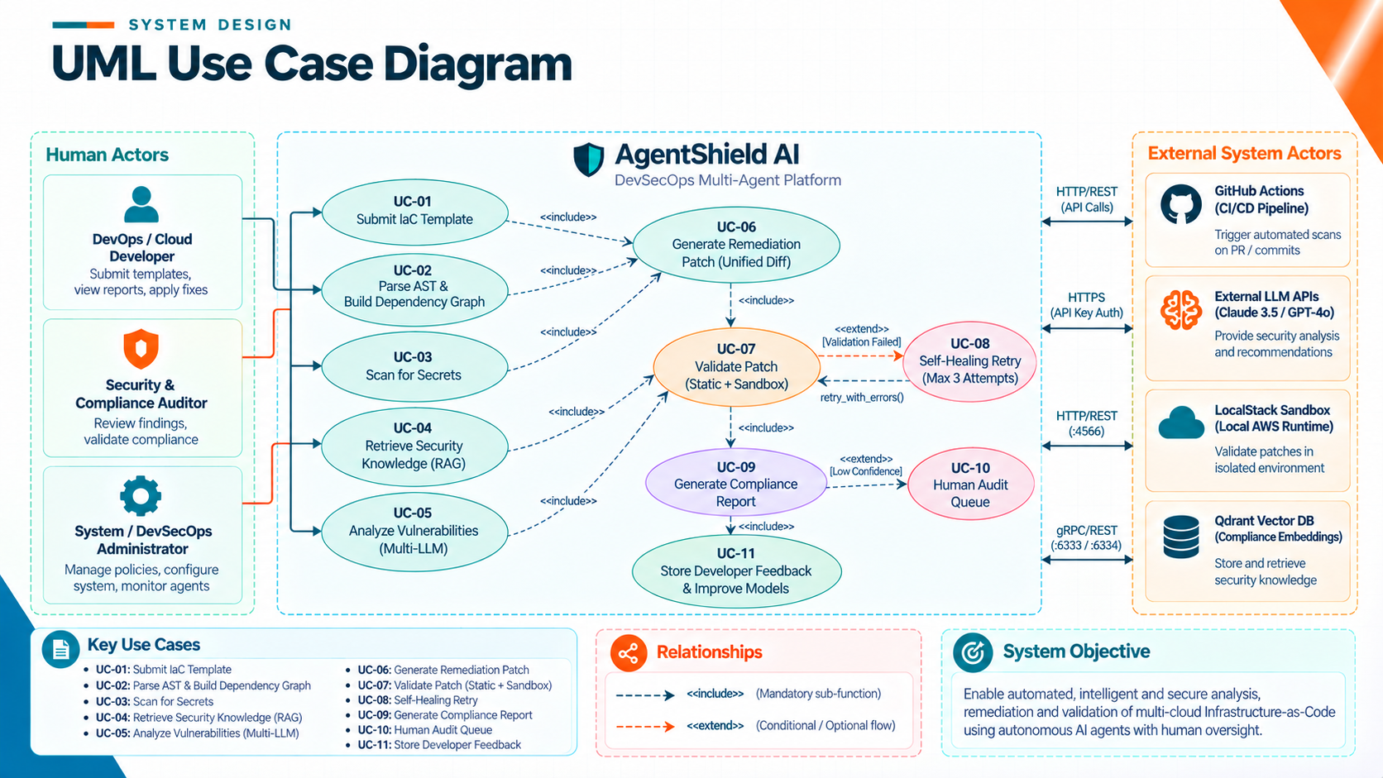
Figure 4.1: UML Use Case Diagram for AgentShield AI Platform
As detailed in Figure 4.1, the platform encompasses three human actor roles and four external system actors:
1. DevOps / Cloud Developer: Submits IaC templates (UC-01), reviews vulnerability findings, and applies verified remediation patches.
2. Security & Compliance Auditor: Reviews security findings, inspects attack-path graphs, and exports compliance reports across CIS, NIST, and HIPAA standards.
3. System / DevSecOps Administrator: Configures consensus thresholds, manages API keys, sets automated retry budgets, and monitors agent telemetry.
4. External System Actors: GitHub Actions CI/CD runner (triggers automated pull request scans), External LLM APIs (provide parallel model inference), LocalStack Sandbox (executes isolated AWS dry-runs), and Qdrant Vector DB (stores and queries compliance embeddings).
The diagram formally specifies mandatory functional inclusions (<<include>>) and conditional extensions (<<extend>>): UC-01 (Submit IaC Template) includes UC-02 (Parse AST & Build Dependency Graph) and UC-03 (Scan for Secrets). UC-05 (Analyze Vulnerabilities) includes UC-04 (Retrieve Security Knowledge). If findings are confirmed, UC-06 (Generate Remediation Patch) is included. UC-07 (Validate Patch) executes static and sandbox checks. If validation fails, the flow conditionally extends into UC-08 (Self-Healing Retry, max 3 attempts). If finding confidence is low (< 0.85), the flow conditionally extends into UC-10 (Human Audit Queue). Finally, UC-09 generates reports and UC-11 captures developer accept/reject feedback.

4.4 Class Diagram / Class Architecture
The Class Diagram models the static structural design of AgentShield AI, detailing the Pydantic v2 data models, immutable state contracts, domain enumerations, and autonomous agent class interfaces. Figure 4.2 presents the complete Class Architecture.
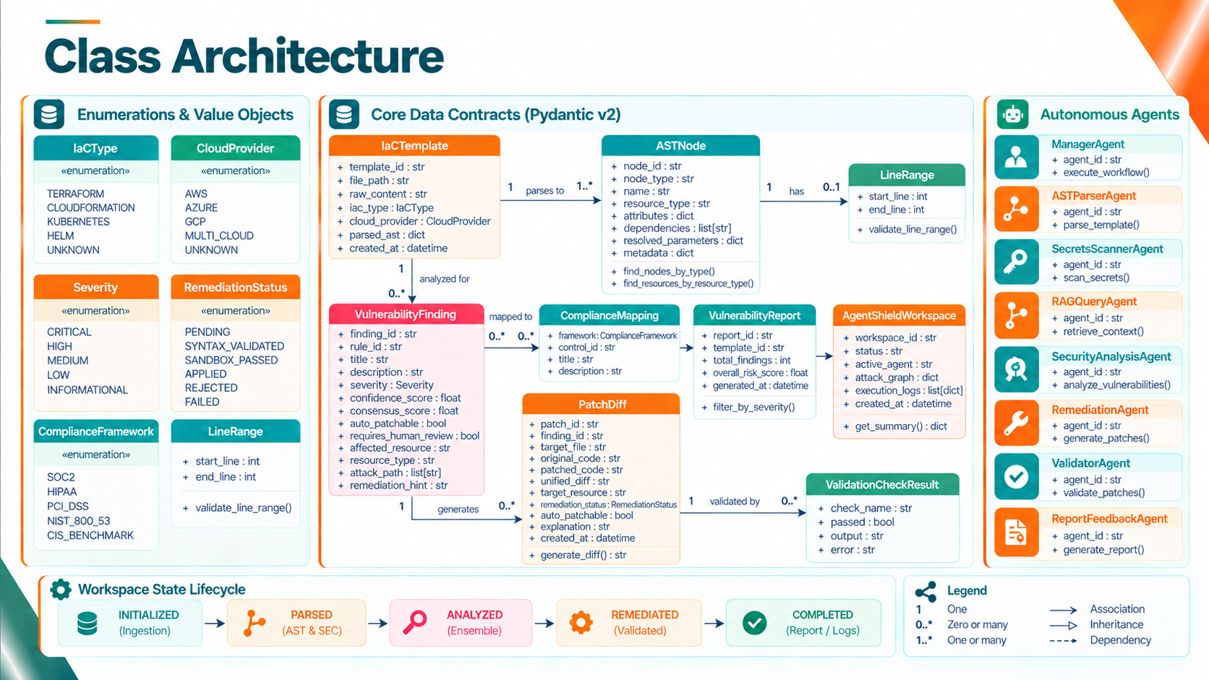
Figure 4.2: UML Class Diagram & Pydantic Data Contracts Architecture
The class architecture establishes four primary structural groupings:
1. Enumerations & Value Objects: IaCType (TERRAFORM, CLOUDFORMATION, KUBERNETES, HELM), CloudProvider (AWS, AZURE, GCP, MULTI_CLOUD), Severity (CRITICAL, HIGH, MEDIUM, LOW, INFORMATIONAL), RemediationStatus (PENDING, SYNTAX_VALIDATED, SANDBOX_PASSED, APPLIED, REJECTED, FAILED), ComplianceFramework (SOC2, HIPAA, PCI_DSS, NIST_800_53, CIS_BENCHMARK), and LineRange (start_line, end_line).
2. Core Data Contracts (Pydantic v2): IaCTemplate (represents input code and parsed AST root), ASTNode (hierarchical tree node with attributes and dependencies), VulnerabilityFinding (finding metadata, severity, confidence, attack path), ComplianceMapping (framework, control ID), VulnerabilityReport (aggregated report summary and risk score), PatchDiff (original code, patched code, unified diff), ValidationCheckResult (check name, pass/fail status, diagnostic error), and AgentShieldWorkspace (top-level session state containing template, report, patches, attack graph, and execution logs).
3. Autonomous Agents: ManagerAgent (execute_workflow), ASTParserAgent (parse_template), SecretsScannerAgent (scan_secrets), RAGQueryAgent (retrieve_context), SecurityAnalysisAgent (analyze_vulnerabilities), RemediationAgent (generate_patches), ValidatorAgent (validate_patches), and ReportFeedbackAgent (generate_report).
4. Structural Relationships: Strict multiplicity guarantees that an IaCTemplate has 1..* ASTNodes; a VulnerabilityFinding maps to 0..* ComplianceMappings and generates 0..* PatchDiffs; each PatchDiff is evaluated by 0..* ValidationCheckResults; and an AgentShieldWorkspace encapsulates the unified state contract.

4.5 Sequence Diagram
The UML Sequence Diagram illustrates the dynamic, chronological message exchanges occurring across the thirteen system participants during an end-to-end security analysis, remediation, and verification run. Figure 4.3 depicts this complete execution trace.
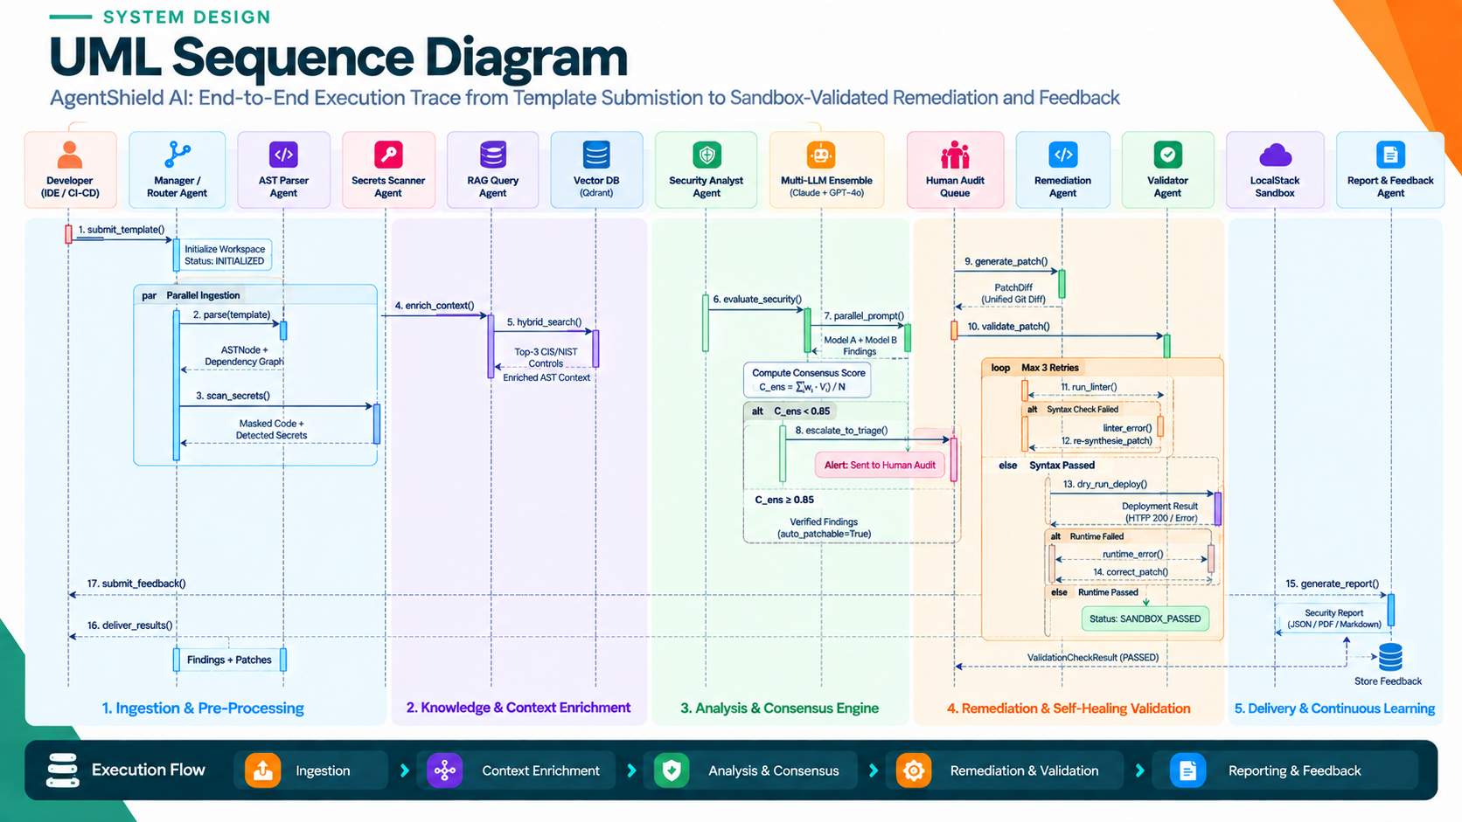
Figure 4.3: UML Sequence Diagram - Execution Trace from Ingestion to Sandbox Remediation
The sequence execution proceeds through seventeen numbered chronological steps organized across five pipeline phases:
Phase 1 (Ingestion & Pre-Processing): 1. The developer submits an IaC template via submit_template(). The Manager Agent initializes workspace status to INITIALIZED. In a parallel block ('par'), 2. the AST Parser parses the template into an ASTNode tree, while 3. the Secrets Scanner intercepts credentials, returning masked code.
Phase 2 (Knowledge & Context Enrichment): 4. The Manager calls enrich_context() on the RAG Query Agent. 5. The RAG Agent invokes hybrid_search() on the Qdrant vector database, returning top-k compliance controls mapped to the declared cloud resources.
Phase 3 (Analysis & Consensus Engine): 6. Security Analyst calls evaluate_security(). 7. The multi-LLM ensemble prompts Claude 3.5 Sonnet and GPT-4o in parallel threads. An agreement formula calculates consensus score C_ens. In an alternative block ('alt'), if C_ens < 0.85, 8. the finding escalates to the Human Audit Queue; if C_ens >= 0.85, verified findings proceed to auto-patching.
Phase 4 (Remediation & Self-Healing Validation): 9. Remediation Agent executes generate_patch() producing a Unified Git Diff. 10. The patch is passed to the Validator Agent via validate_patch(). In a loop block (max 3 retries), 11. static linters run. If syntax check fails, the linter error is fed back to the Remediation Agent for re-synthesis. 13. If syntax passes, a dry-run deploy executes in the LocalStack Sandbox. If runtime passes, status transitions to SANDBOX_PASSED.
Phase 5 (Delivery & Continuous Learning): 15. Report & Feedback Agent generates JSON/PDF/SARIF reports. 16. Results are delivered to the developer. 17. The developer submits accept/reject feedback, which is stored in the Developer Feedback Store for future prompt tuning.

4.6 State Chart Diagram
The State Chart Diagram models the formal discrete state transitions of the AgentShieldWorkspace session container and candidate PatchDiff entities from initial file ingestion to final verified remediation. Figure 4.4 illustrates the state machine architecture.
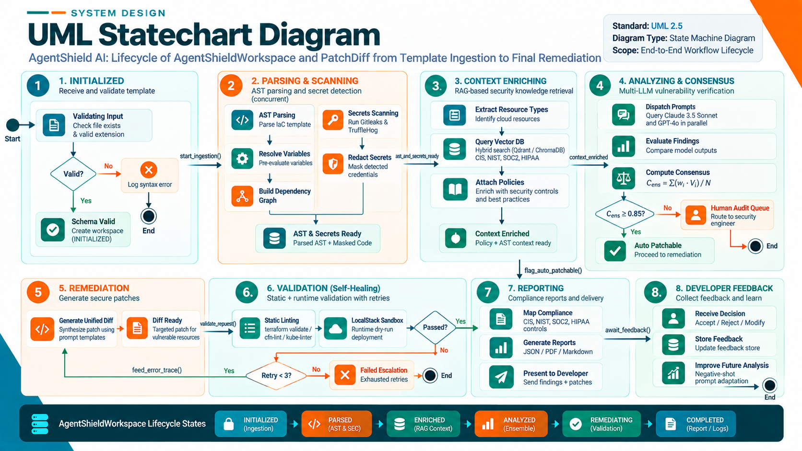
Figure 4.4: UML Statechart Diagram - Workspace & Remediation Patch Lifecycle
As formalized in Figure 4.4, the state machine comprises eight discrete states governed by specific transition guards and actions:
• State 1 (INITIALIZED): The template file is validated for existence, non-emptiness, and valid extension (.tf, .yaml, .json). Invalid inputs transition immediately to an error terminal state.
• State 2 (PARSING & SCANNING): Parallel workers execute AST parsing and credential scanning. Detected secrets are redacted, variable scopes resolved, and dependency graphs generated, transitioning state to PARSED.
• State 3 (CONTEXT ENRICHING): Resource types are extracted and queried against Qdrant and BM25 indices. Compliance control mappings are attached, transitioning state to ENRICHED.
• State 4 (ANALYZING & CONSENSUS): Prompts are dispatched to parallel LLMs. If consensus C_ens >= 0.85, findings are marked auto-patchable; otherwise, findings escalate to the Human Audit Queue.
• State 5 (REMEDIATION): The Remediation Agent synthesizes Unified Git Diffs, setting patch status to PENDING and workspace status to REMEDIATING.
• State 6 (VALIDATION): Static linters and LocalStack sandboxes evaluate the patch. If validation fails and retry count < 3, compiler errors are fed back for re-remediation. If retries are exhausted, the patch transitions to FAILED and escalates to human review. If validation passes, status transitions to SANDBOX_PASSED.
• State 7 (REPORTING): Multi-format reports (SARIF, PDF, Markdown) are generated and delivered, transitioning workspace status to COMPLETED.
• State 8 (DEVELOPER FEEDBACK): Developer accept/reject actions are logged into feedback stores, updating negative few-shot exemplar prompts for subsequent analysis cycles.

4.7 Deployment Diagram
The UML Deployment Diagram illustrates the physical and containerized node topologies, runtime execution environments, microservices, and network communication protocols governing AgentShield AI. Figure 4.5 depicts this deployment topology.
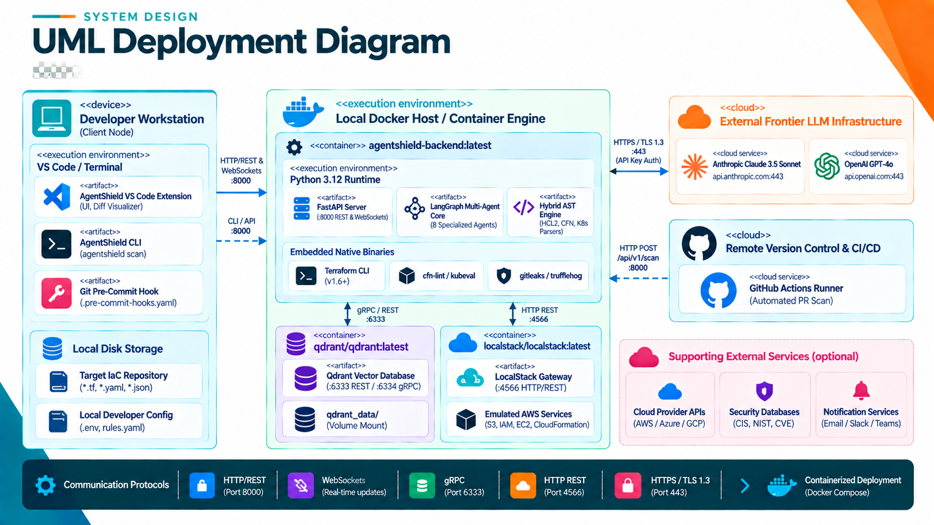
Figure 4.5: UML Deployment Diagram - Containerized Microservices and Cloud Infrastructure
The deployment topology is organized across four distinct computational nodes:
1. Developer Workstation (Client Node): Hosts client execution artifacts including the AgentShield VS Code Extension, the CLI terminal tool (agentshield scan), the Git pre-commit hook (.pre-commit-hooks.yaml), and local repository storage. Communicates with the backend via HTTP/REST on port 8000.
2. Local Docker Host / Container Engine: Hosts containerized microservices managed via Docker Compose. The 'agentshield-backend:latest' container executes a Python 3.12+ runtime containing the FastAPI REST server, the LangGraph multi-agent core, the hybrid AST parser engine, and embedded native linters. The 'qdrant/qdrant:latest' container provides HNSW vector search exposed on gRPC port 6334 and REST port 6333, backed by persistent volume mounts. The 'localstack/localstack:latest' container emulates 45+ AWS APIs on HTTP port 4566.
3. External Frontier LLM Infrastructure: Cloud-hosted model provider endpoints (Anthropic Claude 3.5 Sonnet, OpenAI GPT-4o, Google Gemini) accessed over secure HTTPS/TLS 1.3 on port 443 with encrypted API token authentication.
4. Remote Version Control & CI/CD: GitHub Actions runners executing automated pull request scans via webhook triggers, as well as optional notification services (Email/SMTP, Slack alerts).

4.8 TECHNOLOGIES USED
AgentShield AI integrates an advanced, modern technology stack chosen specifically to maximize performance, type safety, modularity, and security:
• Core Language & Backend Framework: Python 3.12 / 3.13: Chosen for its native asynchronous capabilities, rich AI/ML ecosystem, and enterprise library support. FastAPI provides high-performance ASGI REST endpoints with automated OpenAPI schema generation. Pydantic v2 enforces strict data validation and immutable state contracts at C-speed via pydantic-core.
• Multi-Agent Workflow Engine: LangGraph & LangChain: LangGraph orchestrates the multi-agent execution pipeline as a cyclical state graph, supporting state persistence, conditional edge routing, parallel execution forks, and self-healing error loops.
• Vector Database & Similarity Search: Qdrant Vector Database: High-performance vector database with HNSW (Hierarchical Navigable Small World) indexing, cosine distance metrics, and metadata filtering. Supports embedded local on-disk storage as well as containerized clustering.
• Hybrid RAG & Embedding Models: Rank-BM25 & Sentence-Transformers: Sentence-Transformers generates 384-dimensional dense semantic embeddings using 'all-MiniLM-L6-v2'. Rank-BM25 implements the BM25Okapi algorithm for sparse lexical keyword scoring. Reciprocal Rank Fusion (RRF) mathematically fuses dense and sparse rankings with Bayesian smoothing (k = 60).
• Multi-IaC Parsing Engines: Python-HCL2 & PyYAML: Fast AST parsers for Terraform HCL, CloudFormation, Kubernetes, and Helm templates, extracting resource blocks, attributes, line numbers, and dependencies.
• Attack Path Modeling: NetworkX: Graph-theoretic library used to model cloud resource dependencies as directed graphs (ResourceGraph), calculate downstream blast radius via topological traversals, and identify architectural choke points.
• Validation & Sandbox Harness: LocalStack & Native Linters: LocalStack provides containerized mock cloud runtimes for AWS Terraform and CloudFormation. Static linters (terraform validate, tflint, cfn-lint, kube-linter) provide automated compiler verification.
• Compliance Reporting: ReportLab & SARIF: ReportLab powers automated PDF report rendering with custom tables and risk gauges. SARIF v2.1.0 output integrates natively with GitHub Security and enterprise DevSecOps pipelines.
• Frontend Dashboard: React 18 & Vite: High-speed frontend development environment with modern component-driven UI for vulnerability inspection, diff comparison, and audit queue management.

